# Join Methods

## Task 2: Nested Loop Join

Nested loops joins use each row of the query result reached through one access operation to drive into another table. This join is used here, because:

1.The result set is limited in size

2. There are indexes on the columns used for the join.(deptno is primary key)

SELECT *

FROM scott.emp e, scott.dept d

WHERE e.deptno = d.deptno

AND d.deptno = 10

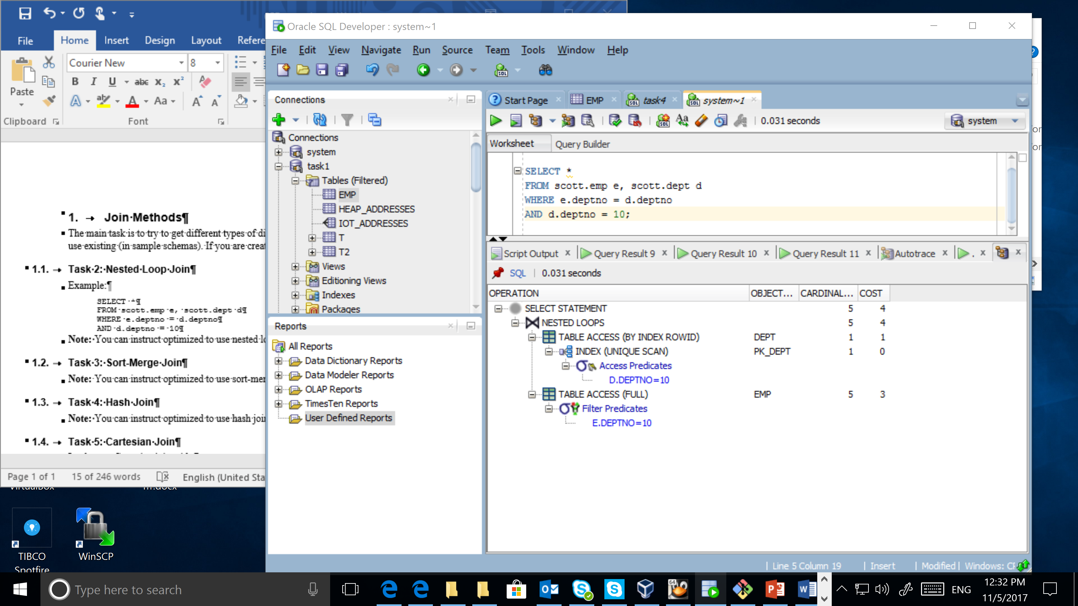

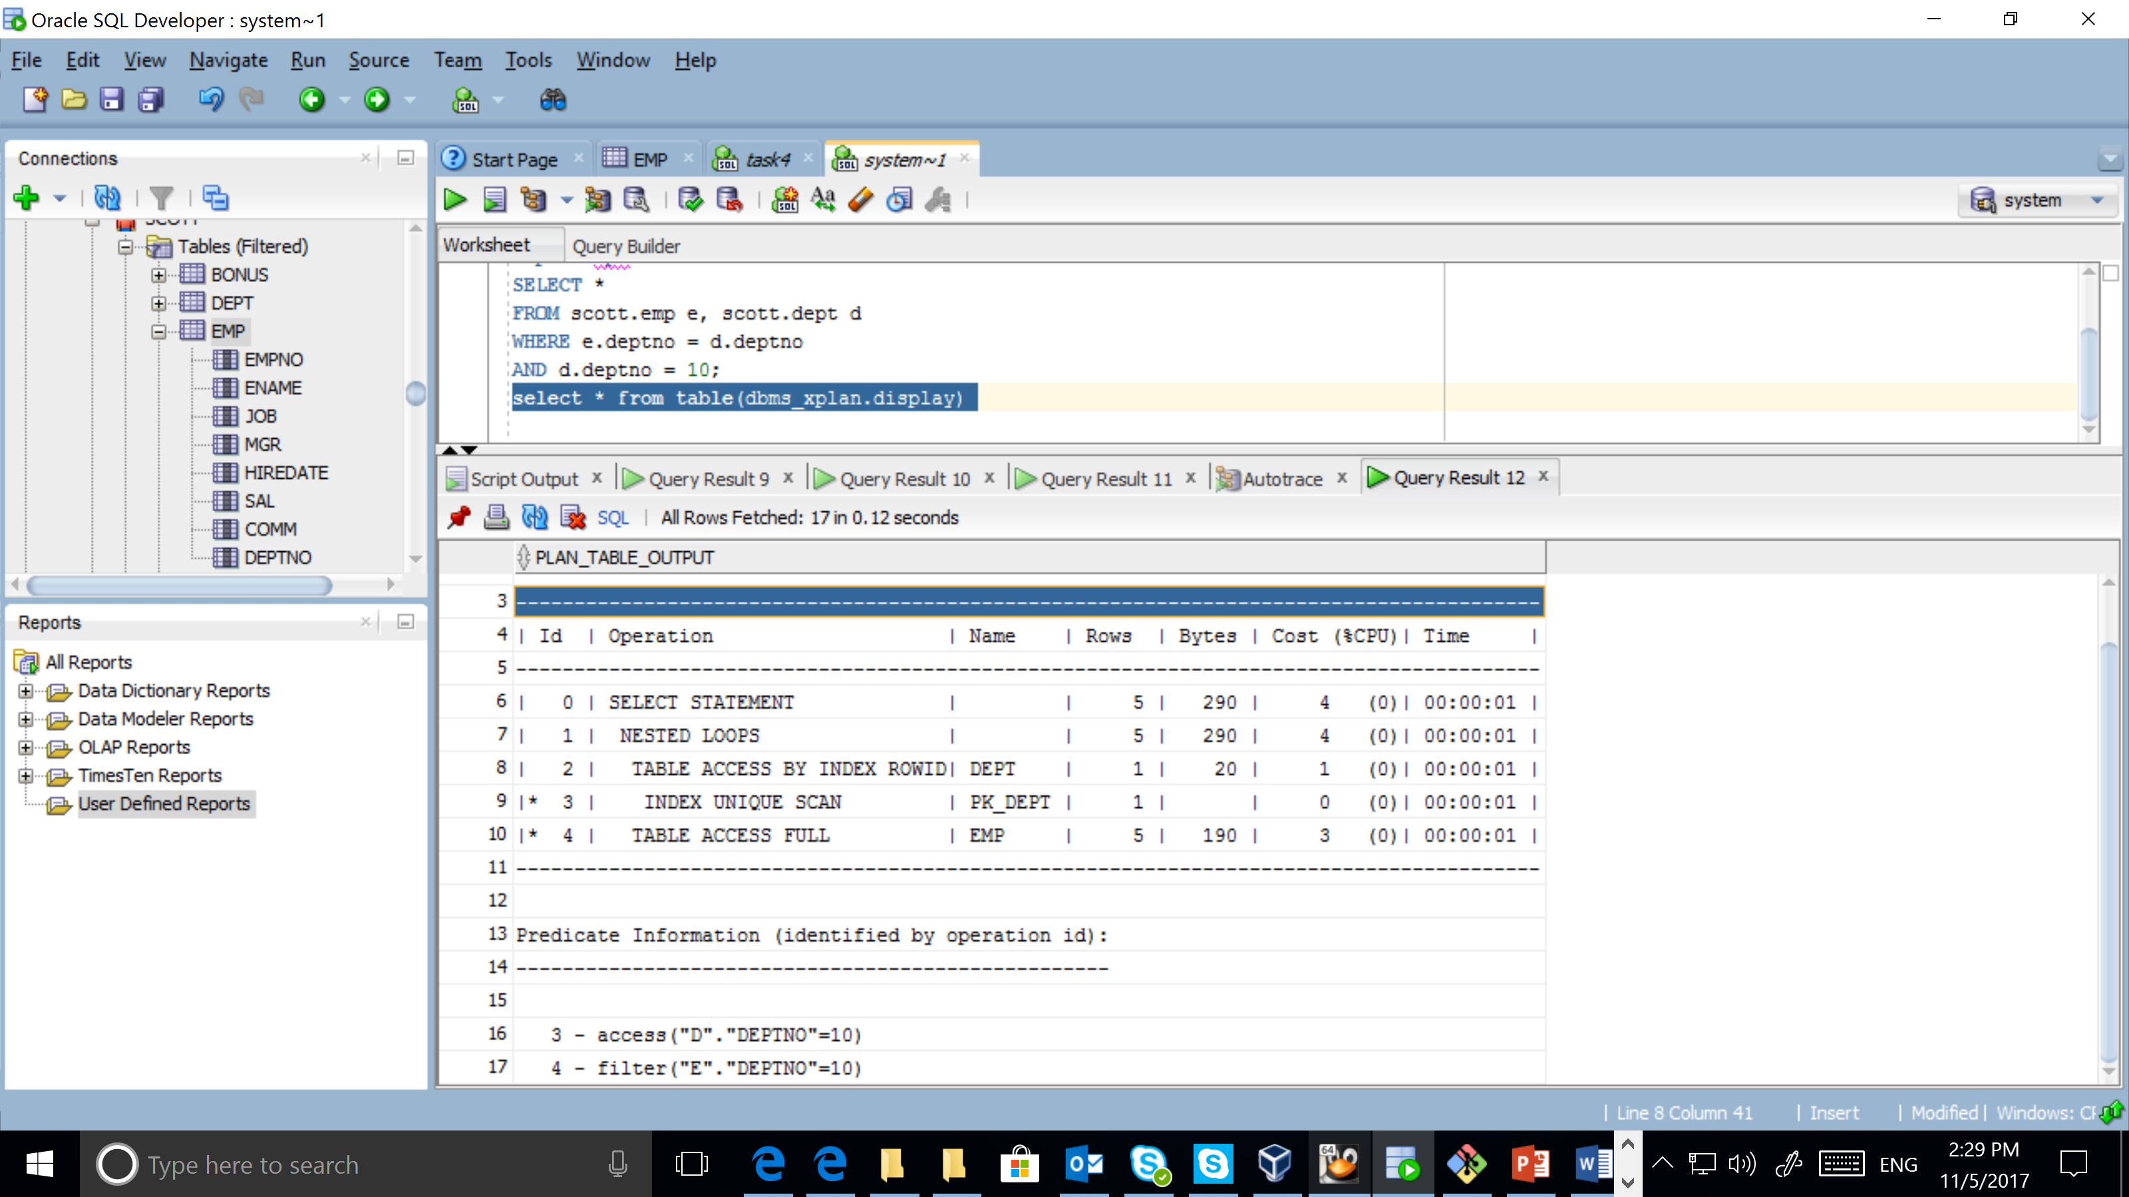

## Task 3: Sort-Merge Join

Sort-merge joins read the two tables to be joined independently, sorts the rows from each table in order by the join key, and then merges the sorted row sets. The sort operations are the expensive part for this join method. For large row sources that won’t fit into memory, the sorts will end up using temporary disk space to complete. In the query sort merge join is used, because it consists order by part.

SELECT *

FROM hr.regions reg, hr.countries cnt

WHERE reg.region_id = cnt.region_id

order by country_name;

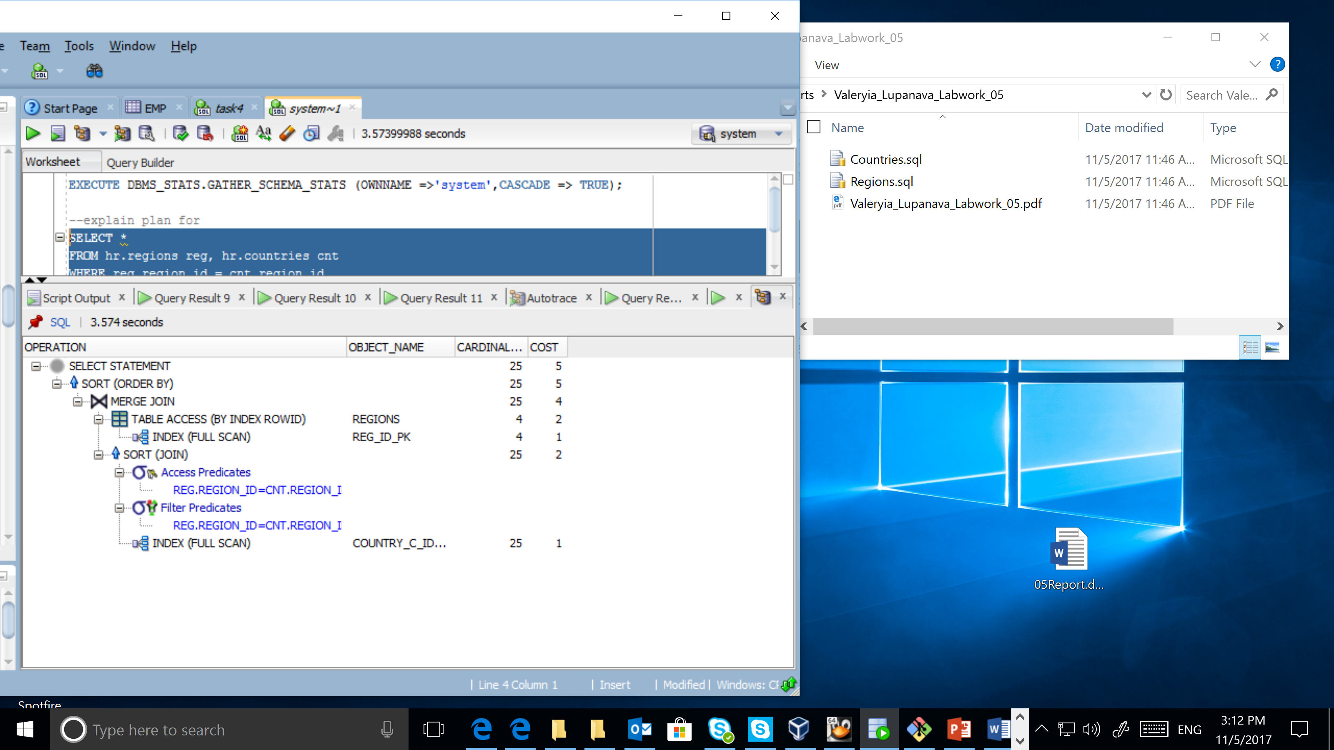

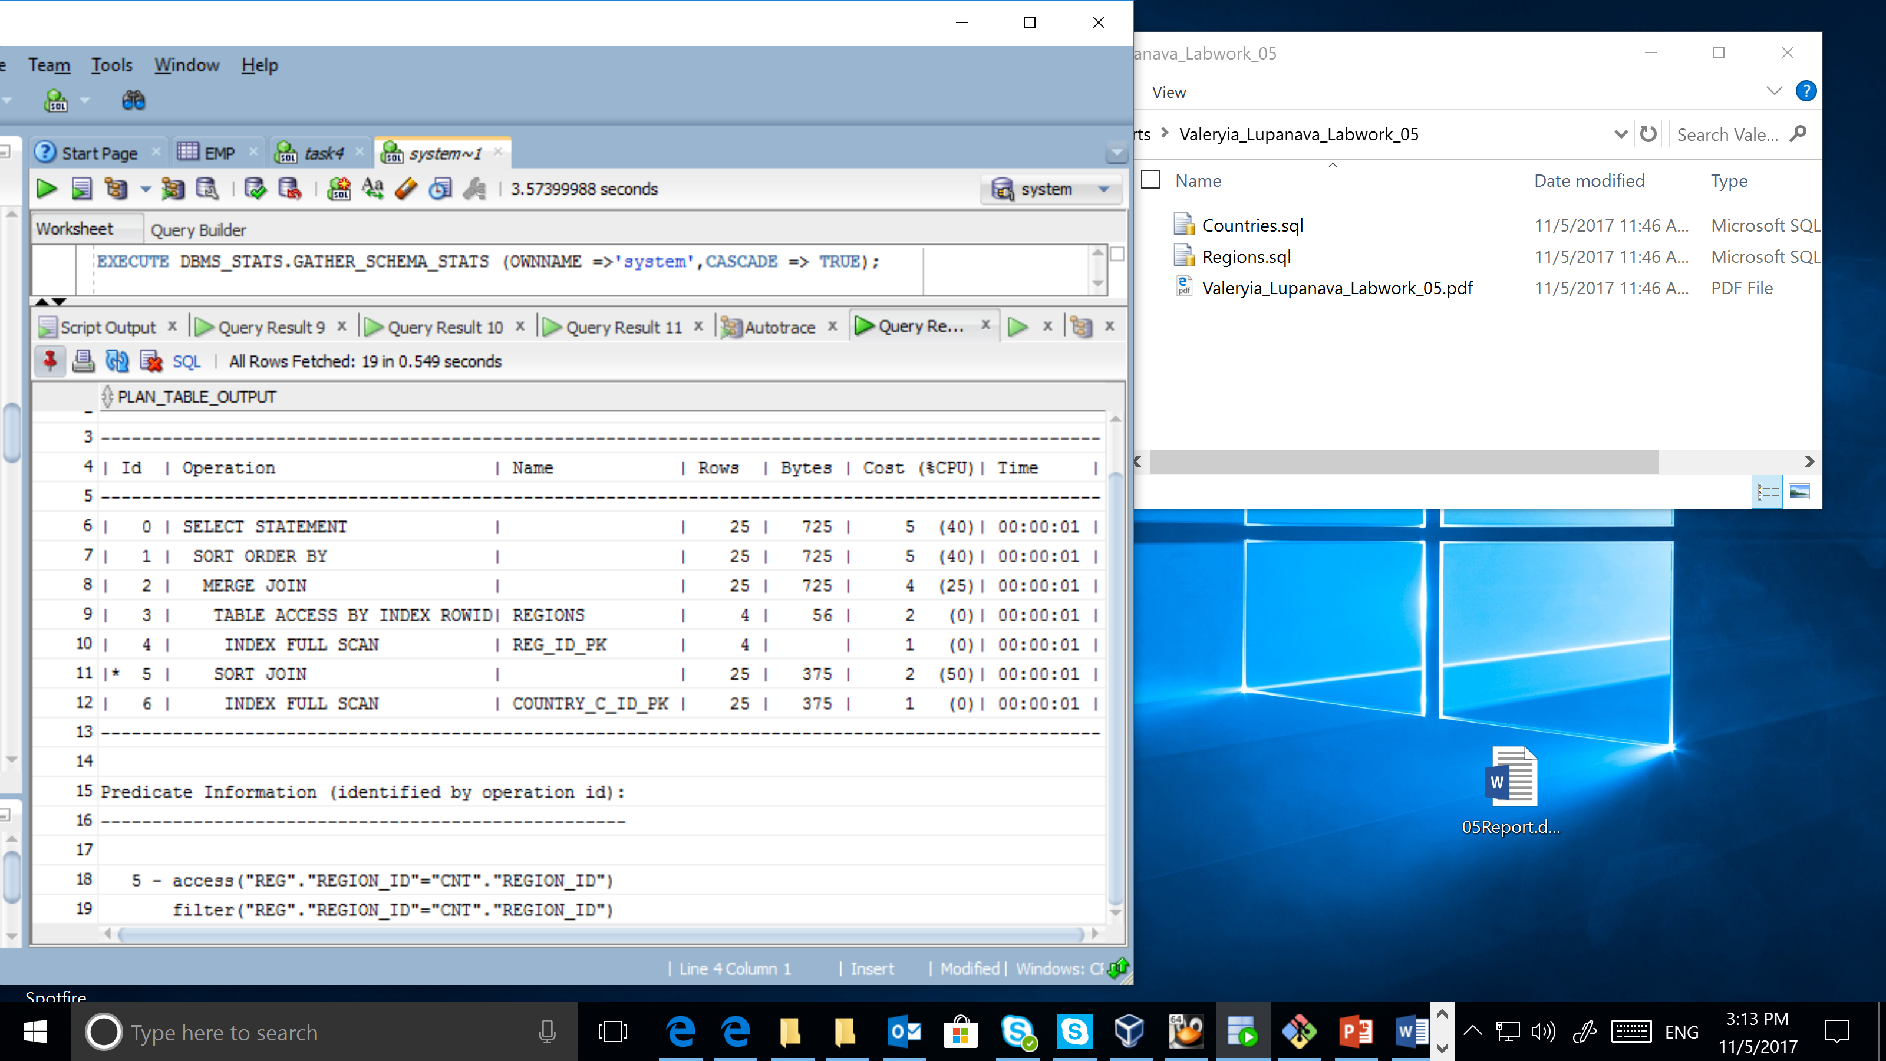

## Task 4: Hash Join

Hash joins first read the two tables to be joined independently and applies the criteria in the WHERE clause. Based on table and index statistics, the table that is determined to return the fewest rows will be hashed in its entirety into memory. This hash table includes all the row data for that table and is loaded into hash buckets based on a randomizing function that converts the join key to a hash value.

The next step is for the other larger table to be read and the hash function is applied to the join key column.

SELECT *

FROM hr.employees emp1, hr.employees emp2

WHERE emp1.manager_id = emp2.employee_id

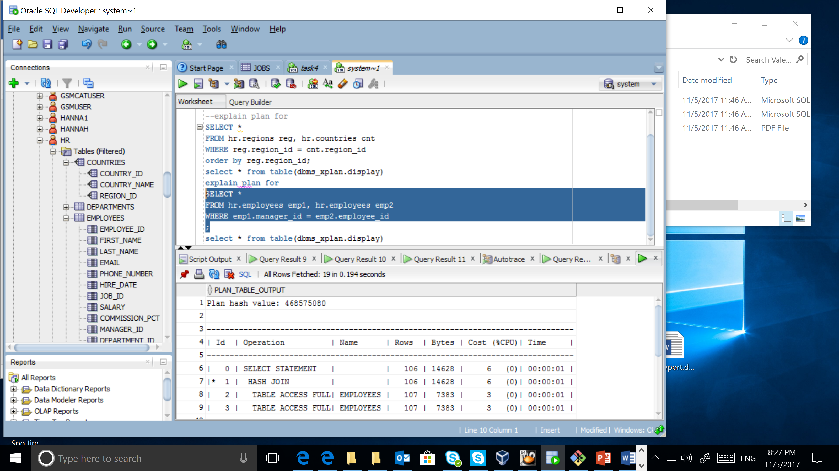

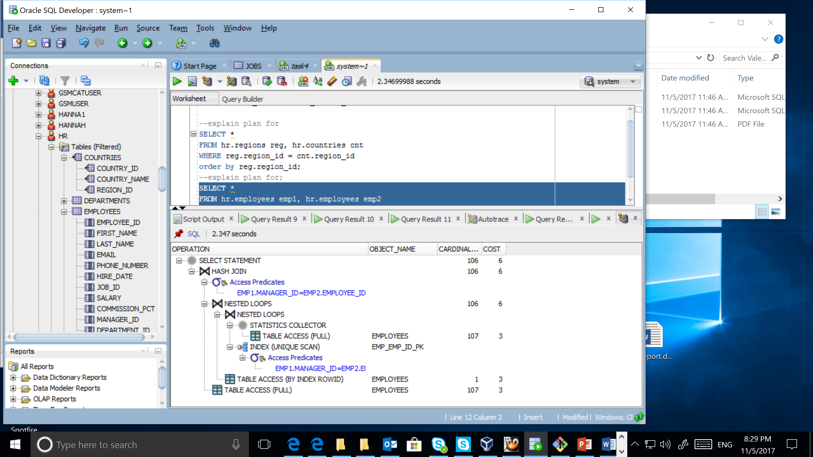

Hash join is used in that case, because tables are quite big.

## Task 5: Cartesian Join

Implement Cartesian join with:

EXPLAIN PLAN FOR SELECT /*+ LEADING(con, reg)*/ *

FROM hr.COUNTRIES con, hr.REGIONS reg;

SELECT * FROM TABLE(dbms_xplan.display);

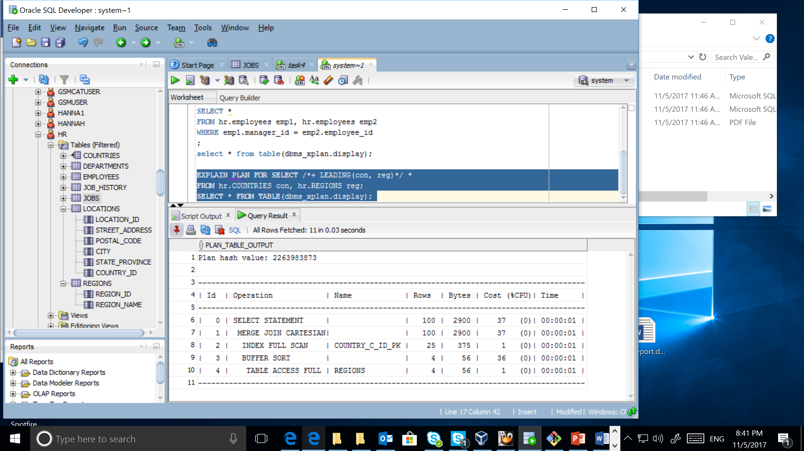

EXPLAIN PLAN FOR SELECT /*+ LEADING(reg, con)*/ *

FROM hr.COUNTRIES con, hr.REGIONS reg;

SELECT * FROM TABLE(dbms_xplan.display);

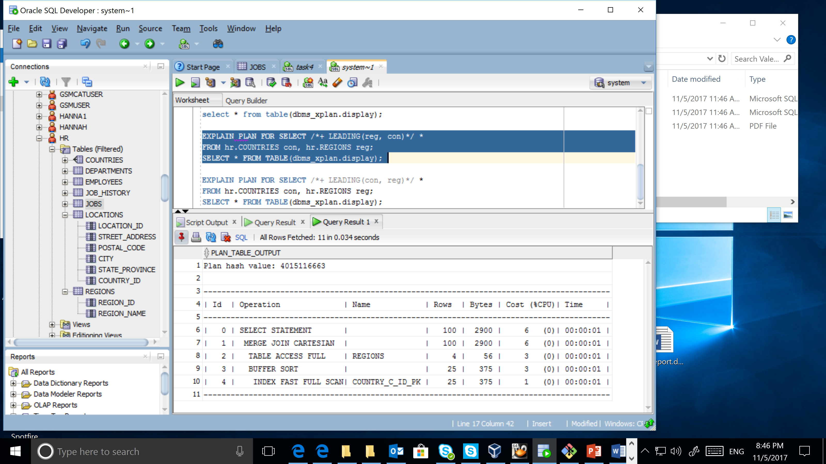

* ORDERED hint and wrong predicate order

.

EXPLAIN PLAN FOR SELECT /*+ ORDERED(con, reg)*/ *

FROM hr.COUNTRIES con, hr.REGIONS reg;

SELECT * FROM TABLE(dbms_xplan.display);

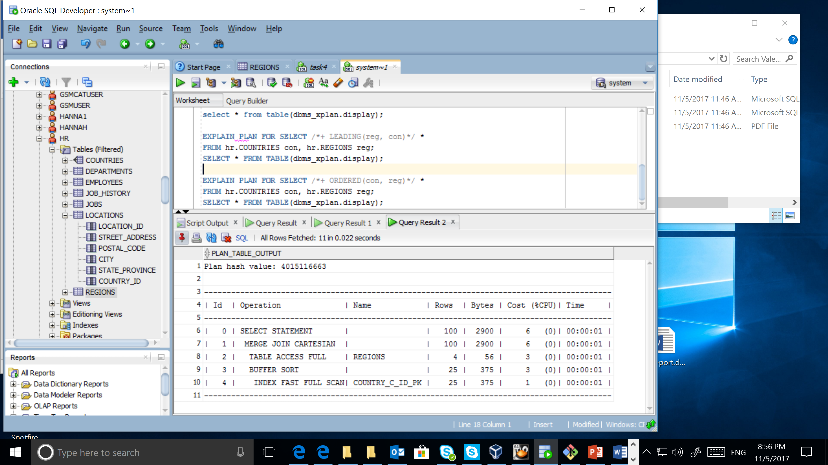

From the example above you could see, that LEADING hint manage the order in which join would be execute, and ORDERED hint is ignored and the optimal order of tables is used. In the example above smaller table is the first.

* W/o join conditions.

EXPLAIN PLAN FOR SELECT *

FROM hr.locations loc, hr.departments dep;

SELECT * FROM TABLE(dbms_xplan.display);

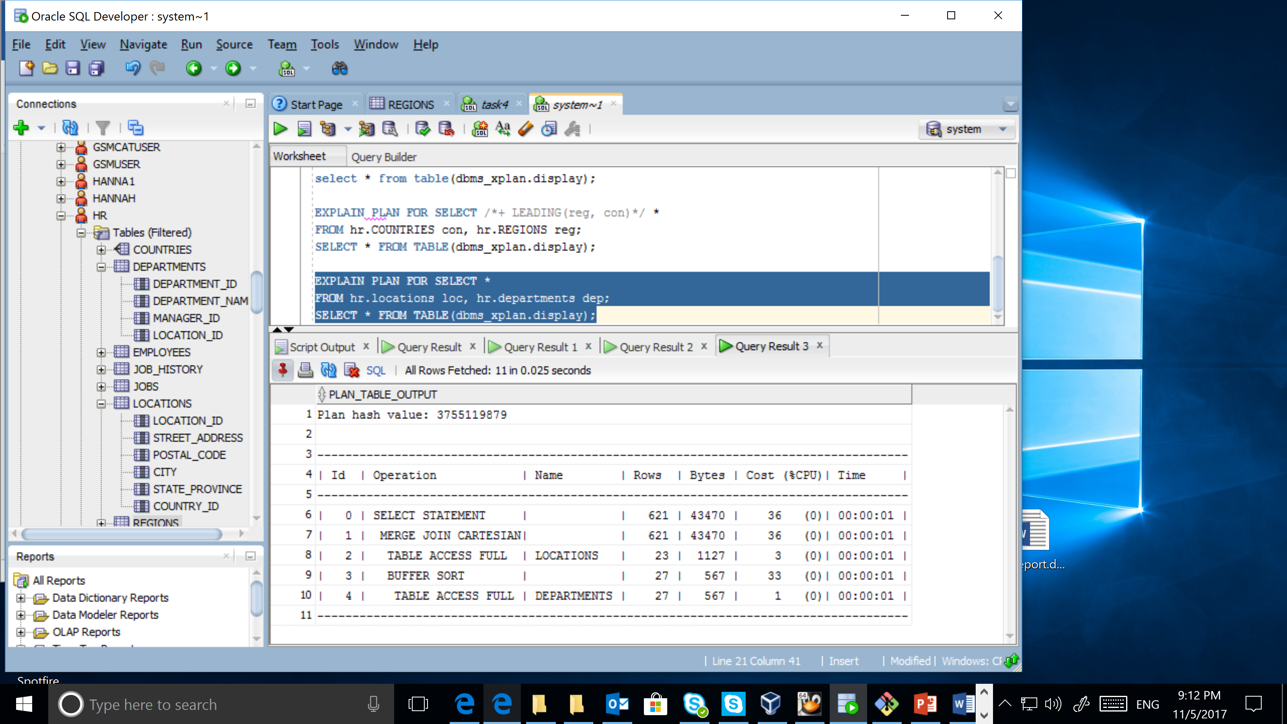

EXPLAIN PLAN FOR SELECT *

FROM hr.locations loc join hr.departments dep

on loc.location_id = dep.location_id

WHERE city = 'Minsk';

SELECT * FROM TABLE(dbms_xplan.display);

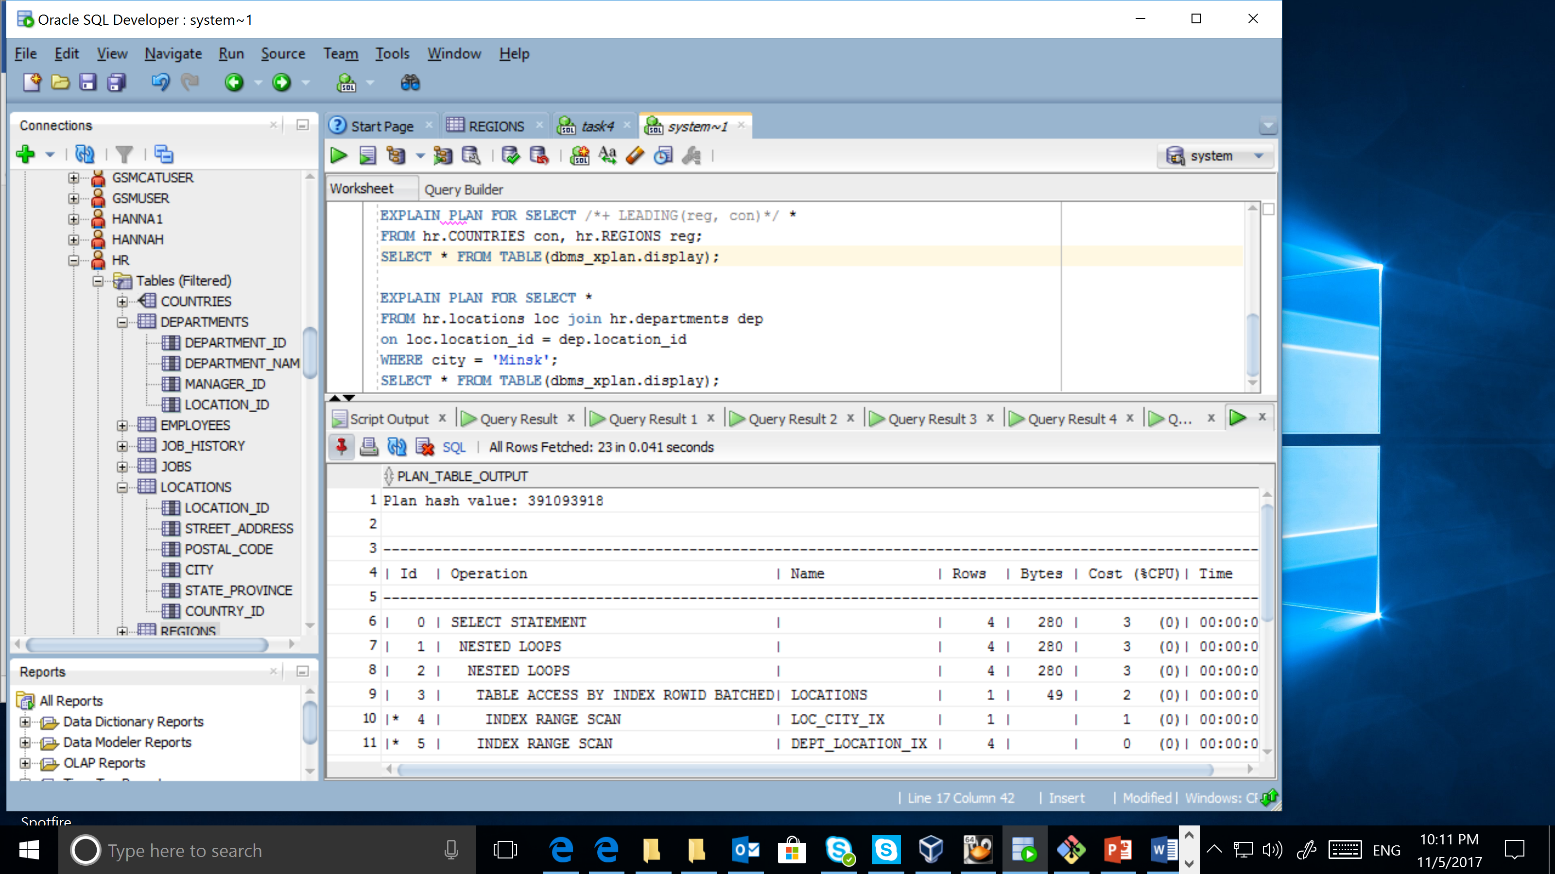

EXPLAIN PLAN FOR SELECT *

FROM hr.locations loc join hr.departments dep

on loc.location_id = dep.location_id

WHERE department_name LIKE '%ing';

SELECT * FROM TABLE(dbms_xplan.display);

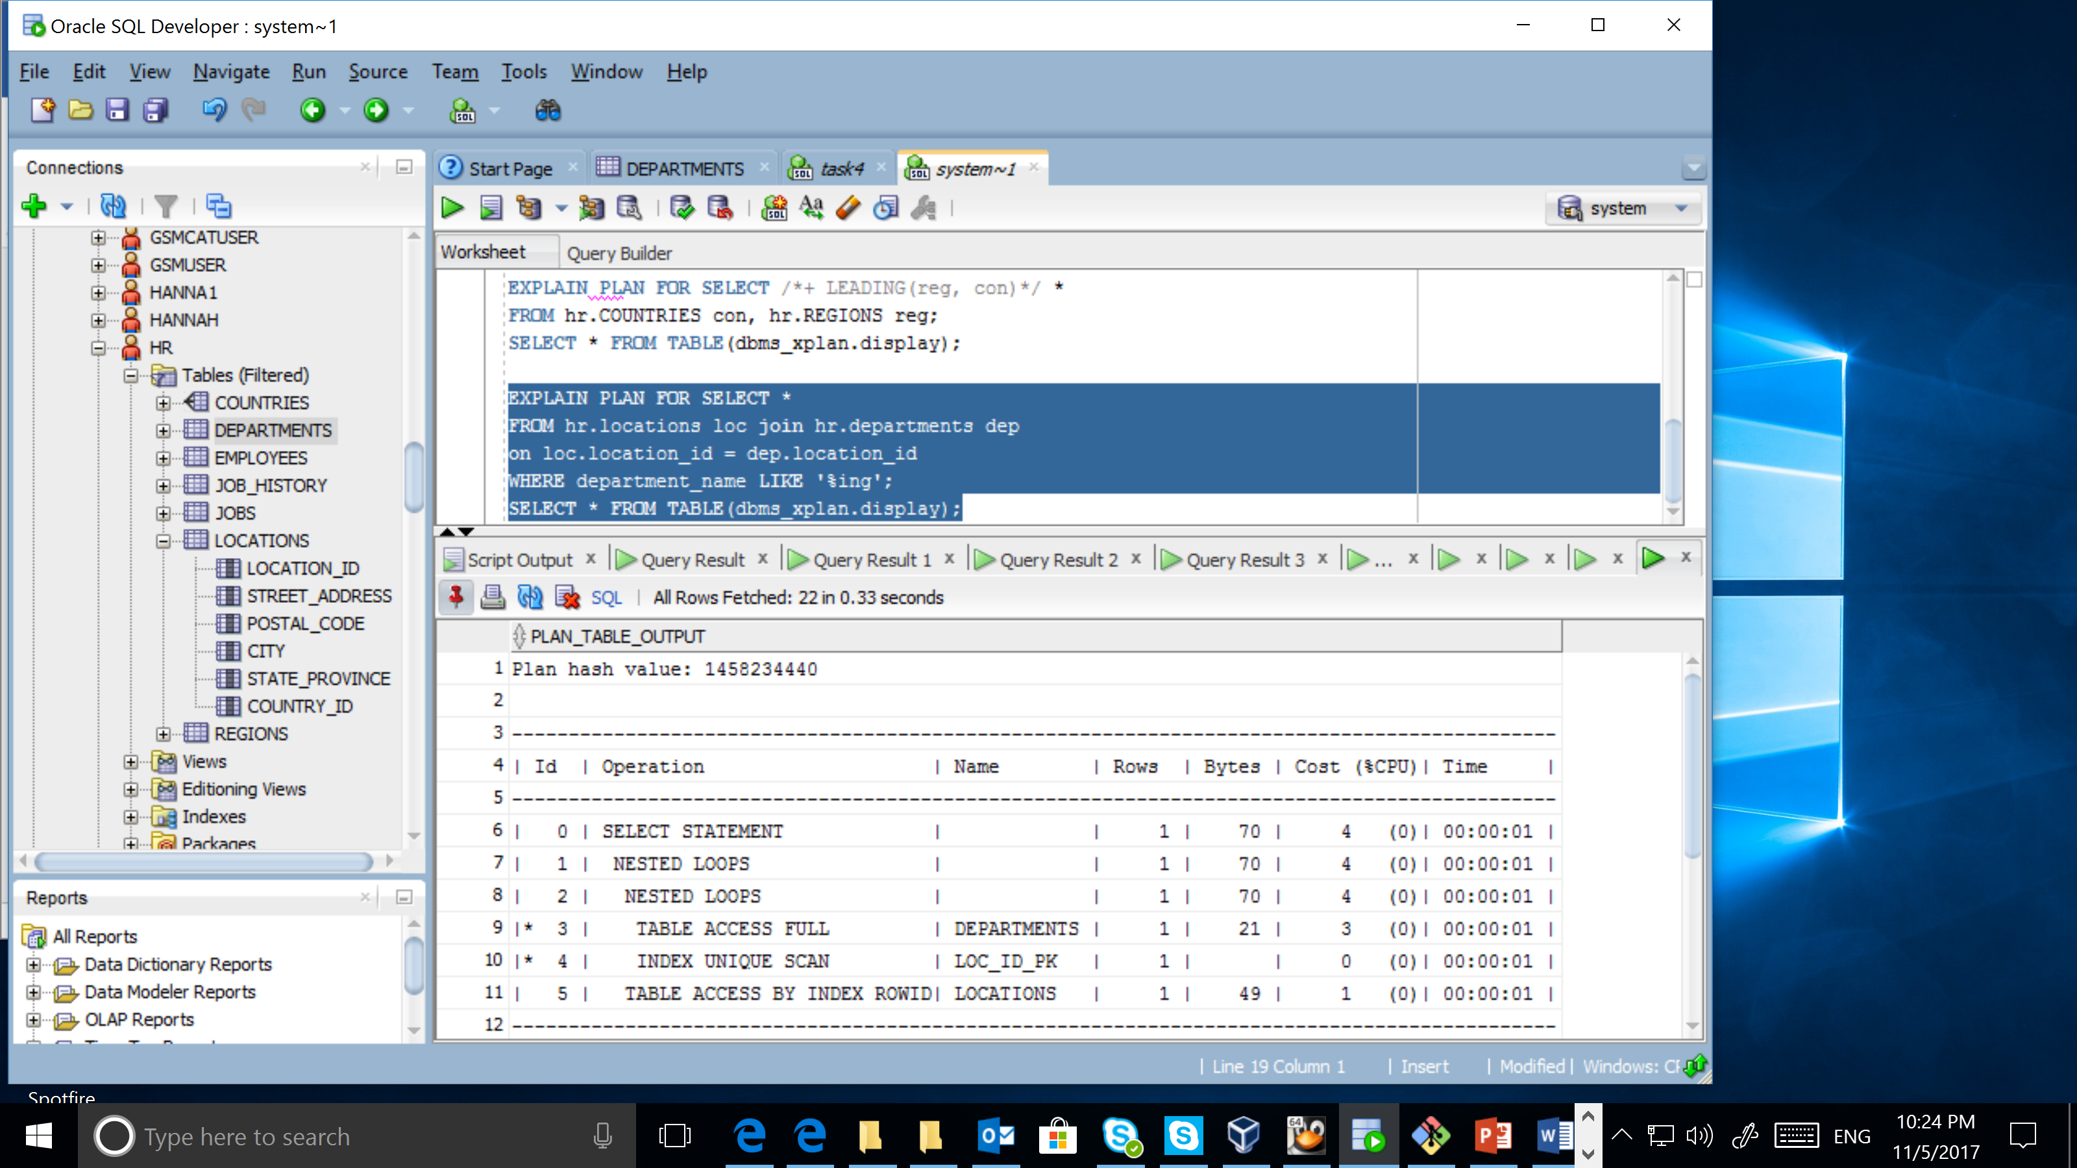

Cartesian join is used only in the case if there are no conditions. If there are some conditions, Cartesian join is not used. In the examples above nested loops is chosen, because tables are not big and data indexes are provided.

## Task 6: Left/Right Outer Joins

Implement Left/Right outer joins with:

EXPLAIN PLAN FOR SELECT *

FROM hr.locations loc right join hr.departments dep

on loc.location_id = dep.location_id;

SELECT * FROM TABLE(dbms_xplan.display);

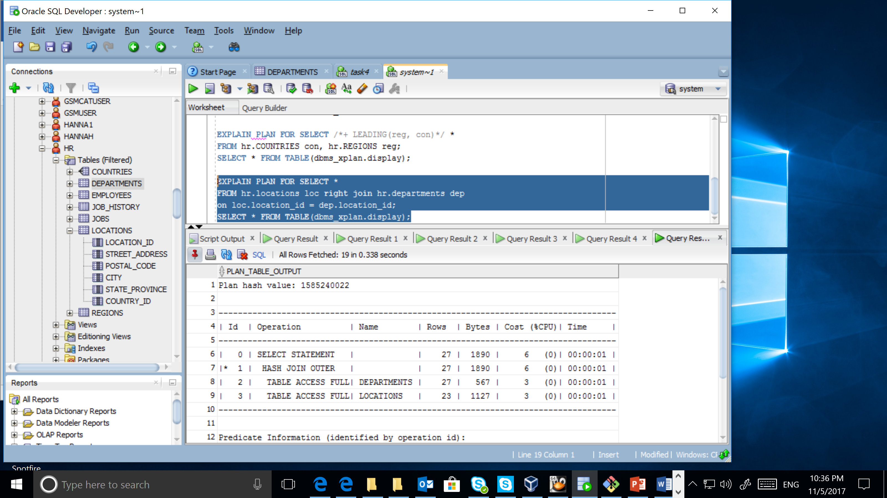

EXPLAIN PLAN FOR SELECT *

FROM hr.locations loc, hr.departments dep

where loc.location_id(+) = dep.location_id;

SELECT * FROM TABLE(dbms_xplan.display);

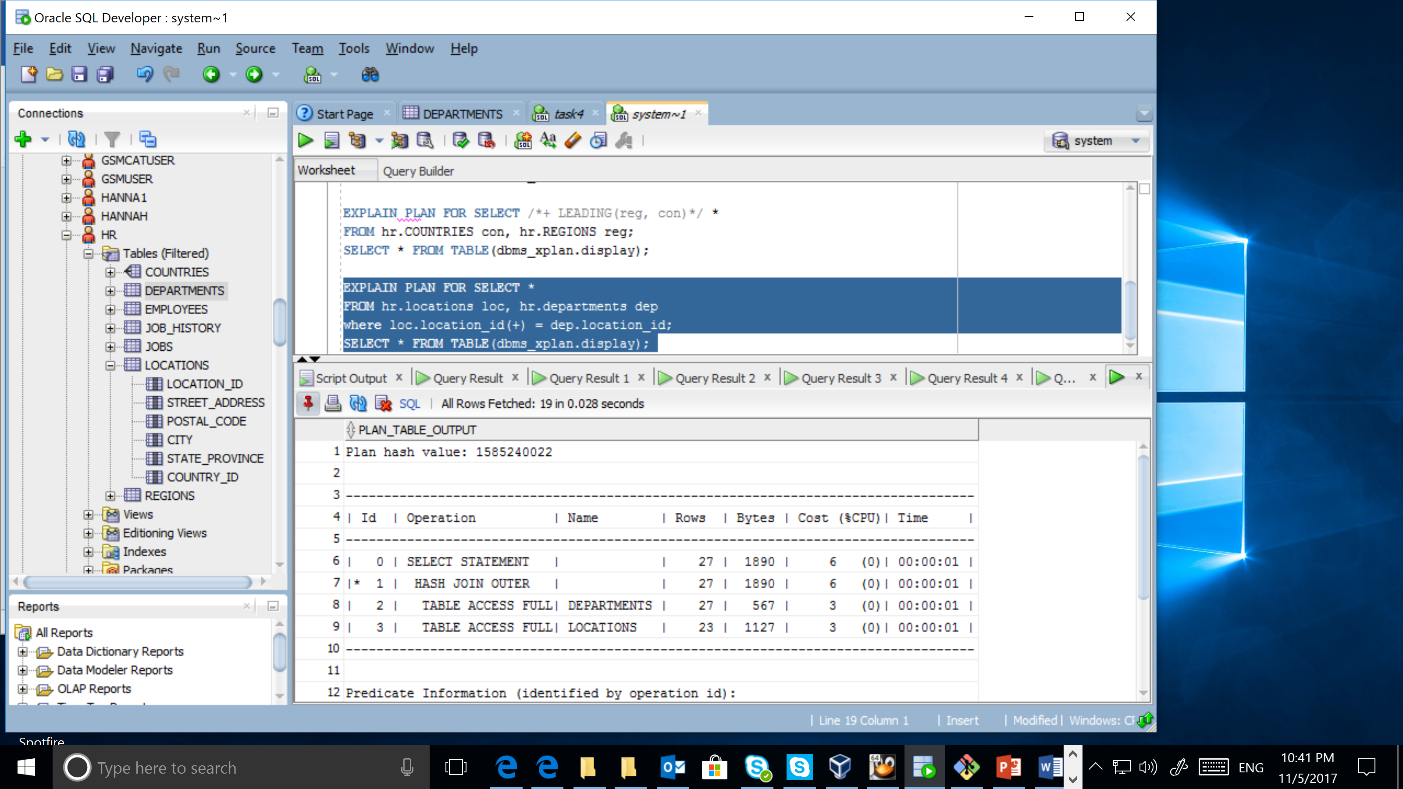

EXPLAIN PLAN FOR SELECT *

FROM hr.locations loc, hr.countries cntr

where loc.country_id = cntr.country_id(+);

SELECT * FROM TABLE(dbms_xplan.display);

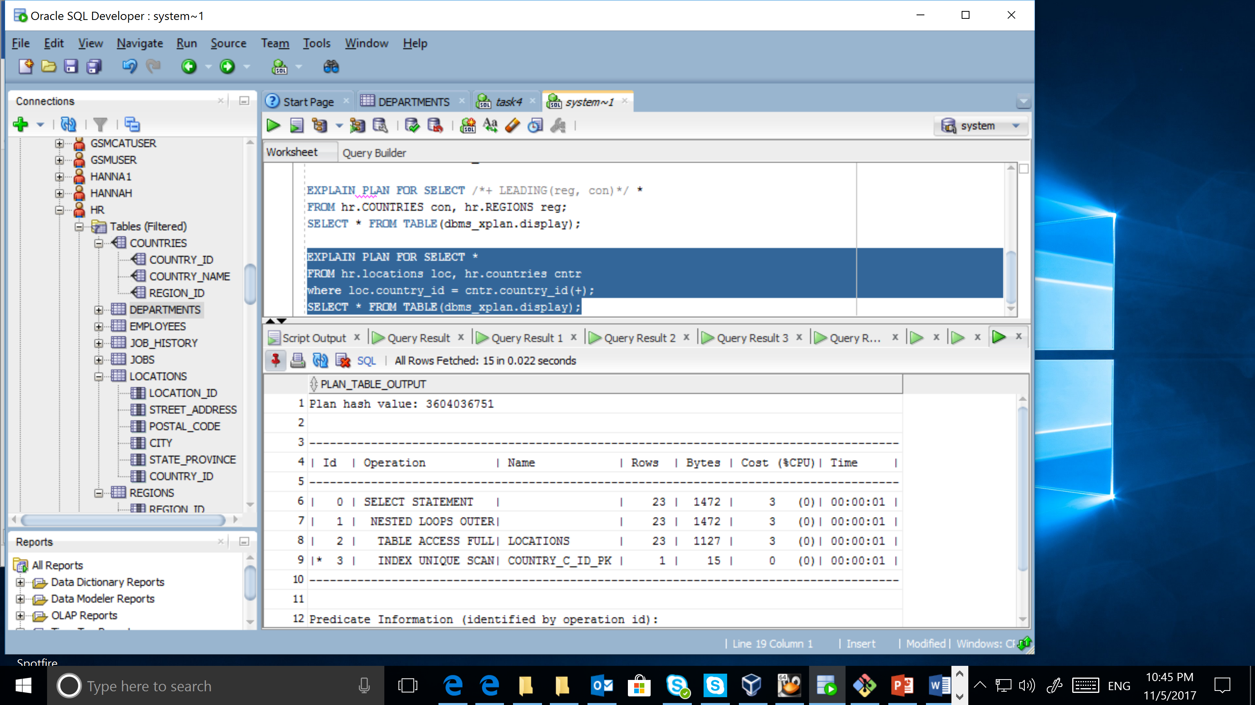

EXPLAIN PLAN FOR SELECT *

FROM hr.locations loc left join hr.countries cntr

on loc.country_id = cntr.country_id;

SELECT * FROM TABLE(dbms_xplan.display);



The statements with different syntaxes have the same execution plan. Nested Loop is used because one table is not big and indexes are provided. Hash join is used when both tables are large enough.

## Task 7: Full Outer Join

EXPLAIN PLAN FOR SELECT *

FROM hr.locations loc outer join hr.countries cntr

on loc.country_id = cntr.country_id;

SELECT * FROM TABLE(dbms_xplan.display);

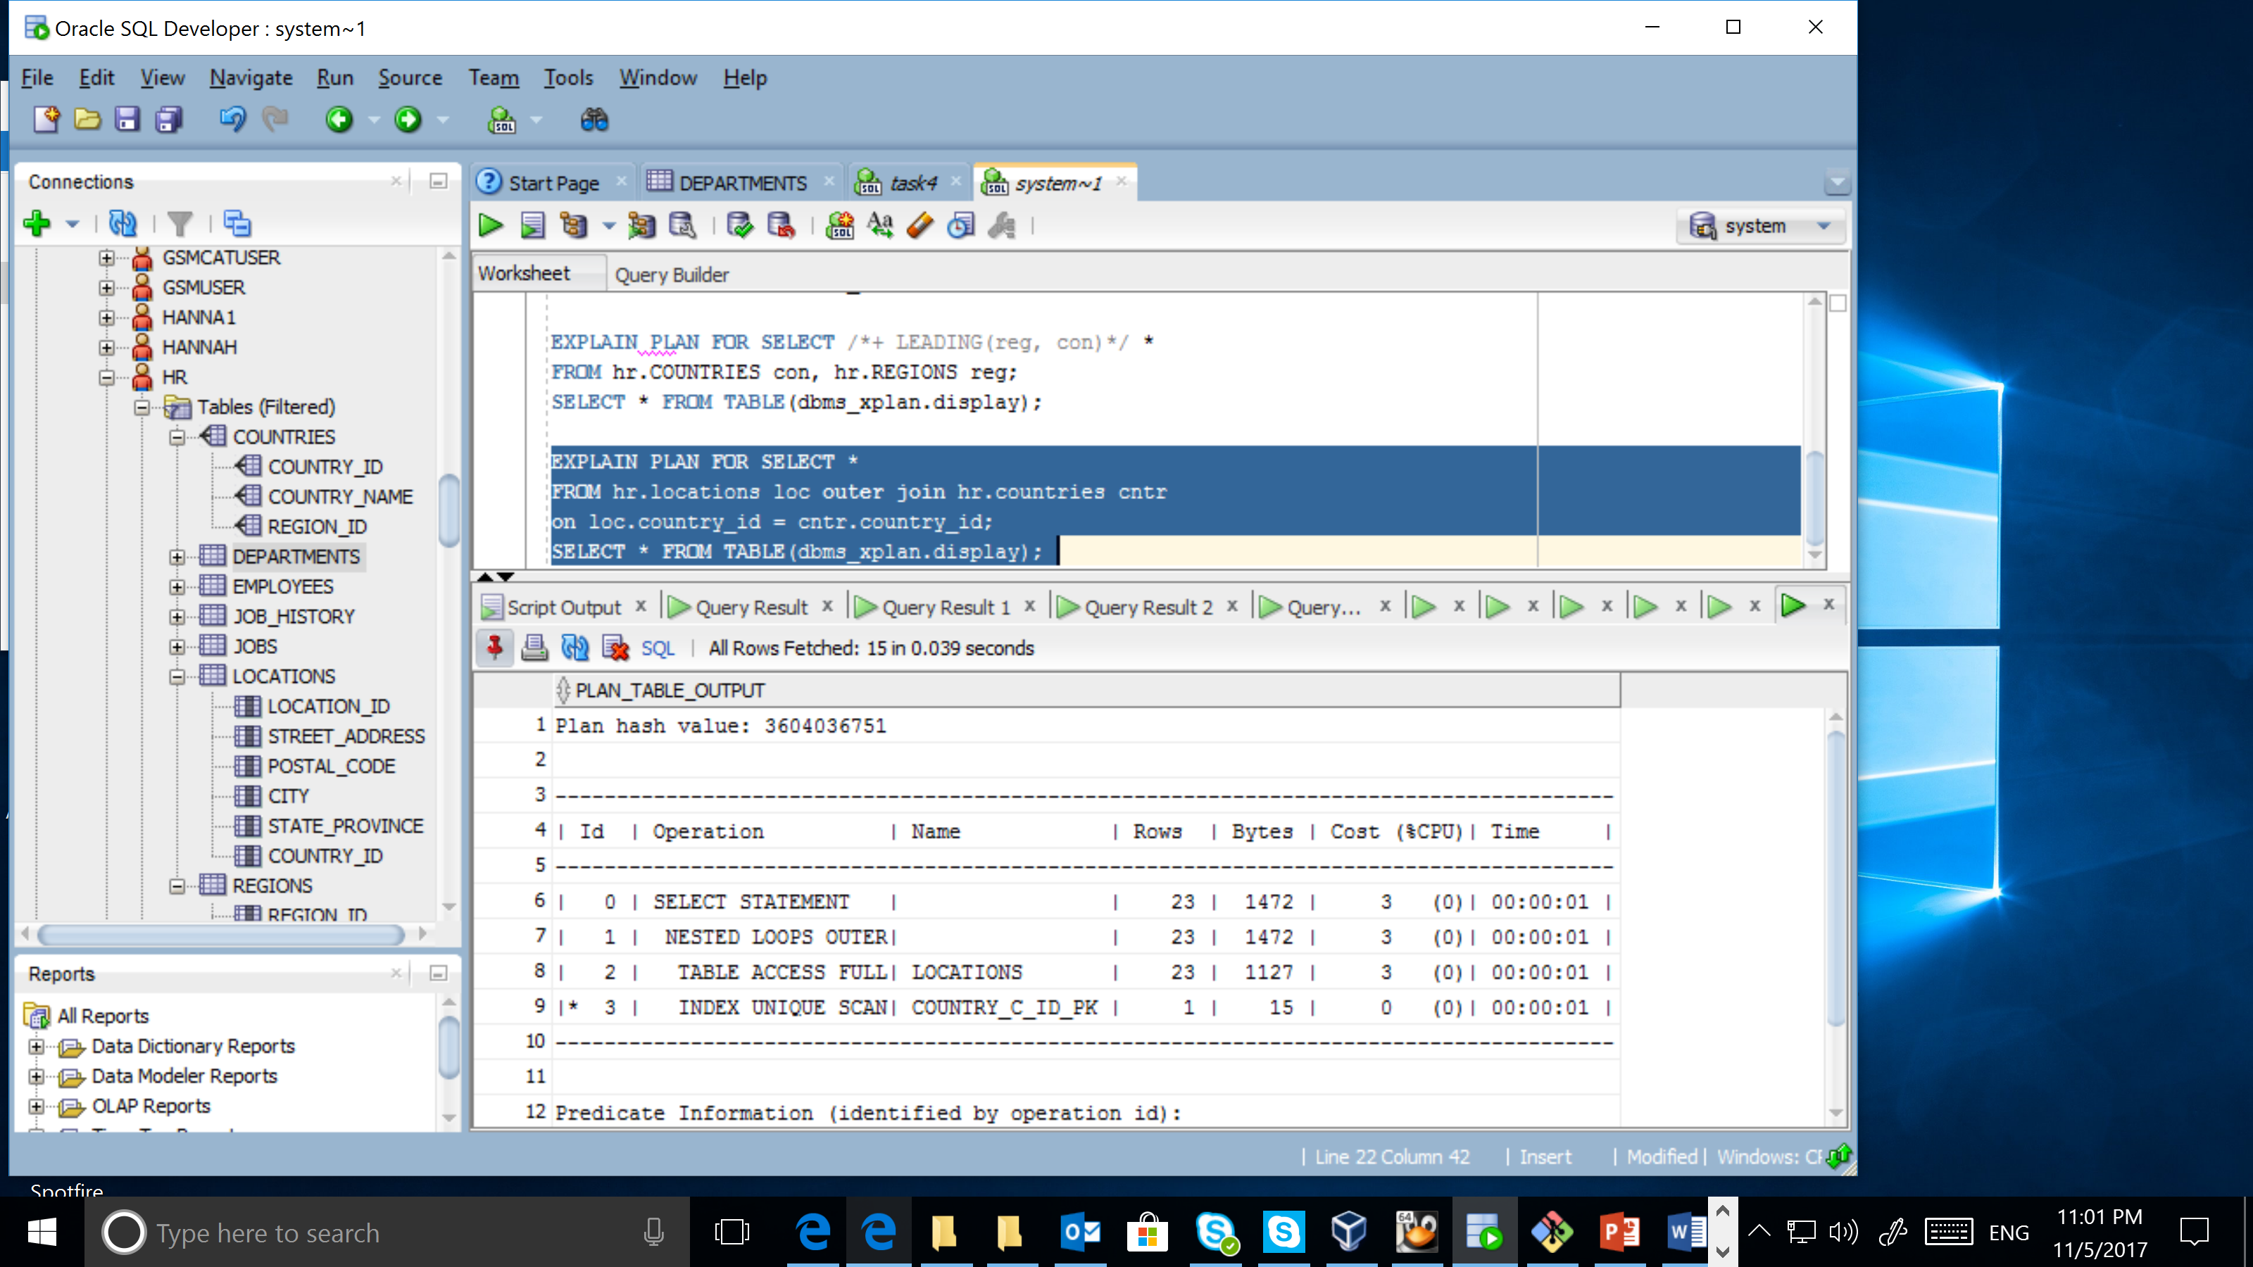

Nested Loop is used because one table is not big and indexes are provided. Hash join is used when both tables are large enough.

EXPLAIN PLAN FOR SELECT *

FROM hr.locations loc, hr.countries cntr

where loc.country_id = cntr.country_id(+)

union

SELECT *

FROM hr.locations loc, hr.countries cntr

where loc.country_id(+) = cntr.country_id;

SELECT * FROM TABLE(dbms_xplan.display);

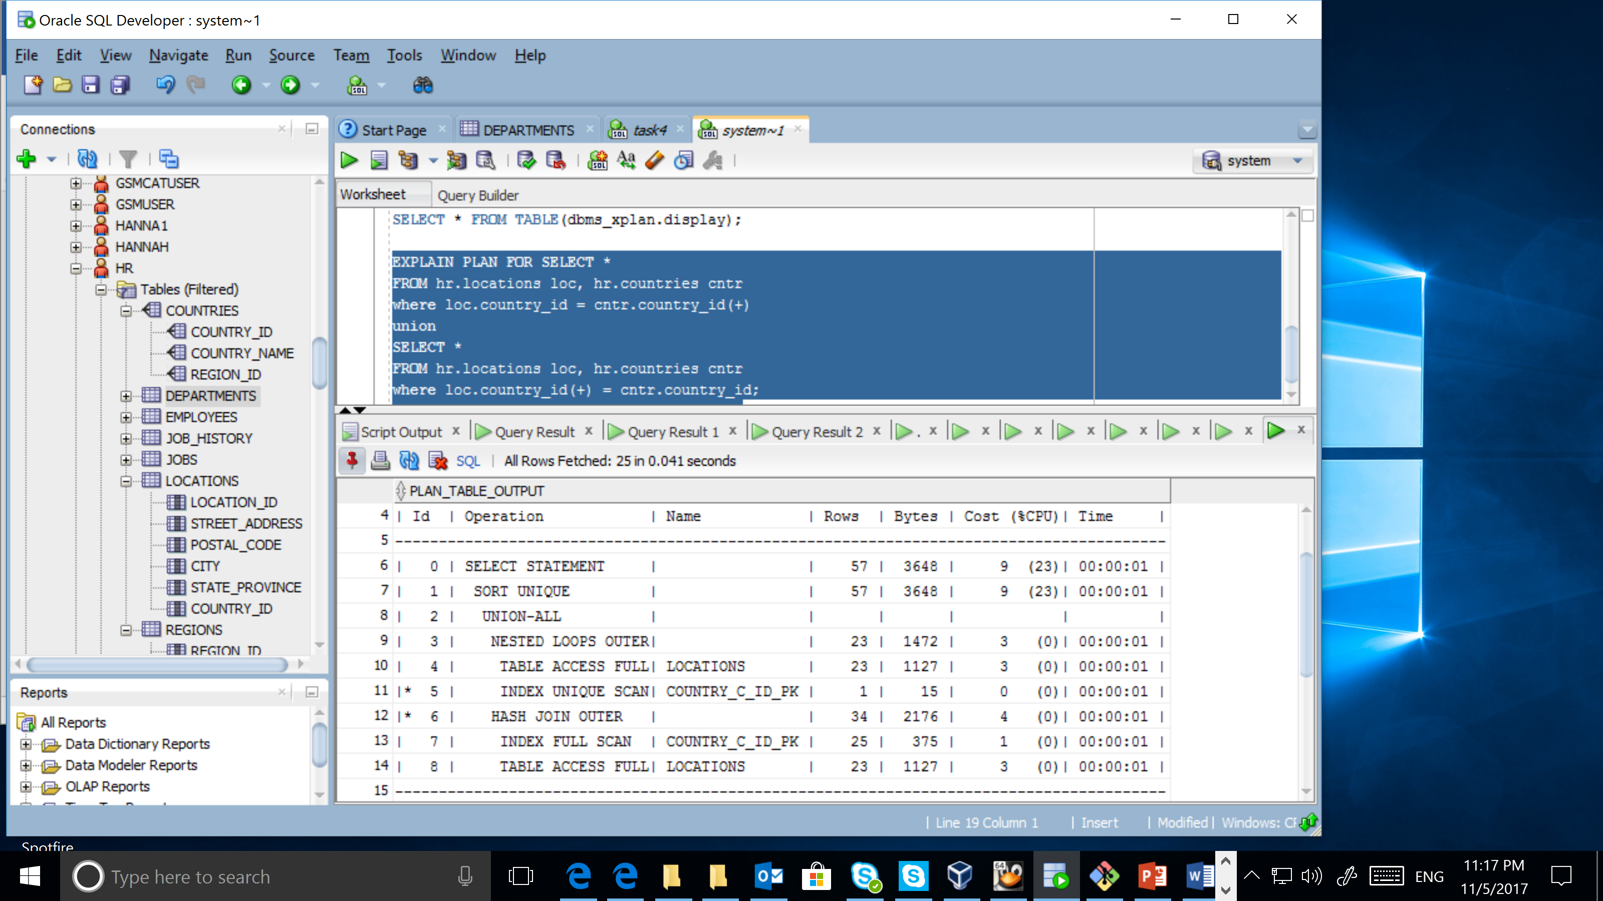

In the example above you could see, that full outer join by oracle syntax cost more than by ansi syntax. It is obvious because using of oracle syntax require two joins, wchich is difficult operations. Hash join and nested loop join were used here.